**Assignment No-1**

**Objective:** **Design a Frame in HTML where all information about college should be display as you are seeing in view(output). In footer please design a watch and display date. In college details please follow-**

**1)About the college**

**2) Vision and Mission & Quality policy**

**3) Accreditation.**

**Prerequisite:** Frame designing in HTML, Target setting of Page, CSS, and JavaSrcipt

**Skilled Developed:** Student shall be able to design the page with different view.

**Description:**

In this application a web page can be divided in different view such as rows and columns.

Each row can have the different information about the application and same with column also.

**Expected Input:**

Divide the page in rows and columns with information about the application.

**Expected Output**

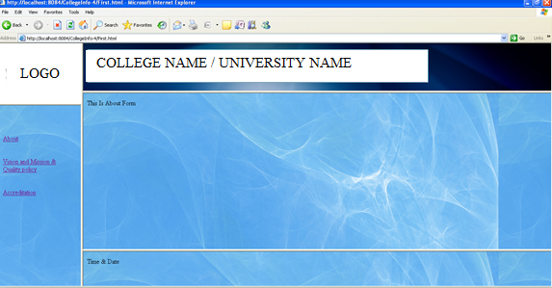

**References:**

1. *Web Technologies- A computer science perspective By Jeffery C. Jackson, Pearson*
2. *Web Technologies-TCP/IP Architecture, and Java Programming By Achyut S. Godbole*
3. *Web Technology-A Developer’s Perspective by N.P Gopalan,J.Akilandeswari,PHI Learning*

**FAQ**

1. What is frameset tag in html
2. How to set the target of page in html frame.
3. What is date object in JavaScript.
4. What is <div> tag in html.